**Laser Project**

**125 poker chips and carrying box**

**Prepared for Bainbridge BARN, ETA Studio - bainbridgebarn.org**

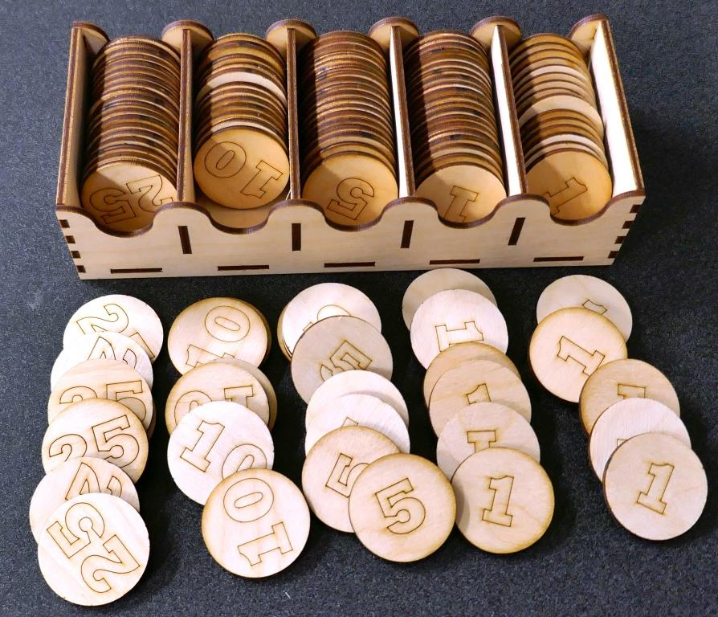

# Overview

In this project, you will use 2 pieces of 300mm x 500mm raw material to make 125 poker chips, plus a box to store them in. You'll make 50 chips with "1", and 25 each of "5", "10", and "25", Plus a few extras in case some turn out to be losers. Total etching and cutting takes a total of about 20 minutes on Little Blue and 15 minutes on Big Red, but figure 1-1.5 hours to complete the project.

# Material required

* 2 sheets 300 x 500 3.2mm thick MDF or Plywood
* White glue

# Difficulty level

This project difficulty level is: EASY. You'll practice the laser skills you learned in your intro class, and detailed instructions are provided for every step.

|  |
| --- |
| **Safety First**   1. **Always follow the safety procedures you learned in the laser class.** 2. **Steps for using the laser are posted. Follow them.** 3. **We were all beginners once. If you have a question, ask a monitor for help.** 4. **Never try to run the laser with the lid open.** |

OK, Let's get started…

**TASK 1 - Get prepared**

|  |  |  |
| --- | --- | --- |
| **1** | Get two pieces of material that are 300mm x 500mm and 3.2mm (1/8") thick. These can be purchased from the ETA studio material stock cupboard. 3.2mm Baltic Birch plywood is recommended, but MDF will also work. You can also be really fancy and cut your chips from acrylic. | Ask the studio monitor for assistance purchasing the material. |
| **2** | Verify your material thickness using calipers. They are located in the toolbox, usually the bottom drawer. | Knowing the material thickness is important because the thickness of the material determines the size of the holes in the box and also the overall size of the box. |
| **3** | Download two files from the ETA github projects folder – "96 poker chips - EASY.lbrn" and "chip box + 32 chips - EASY.lbrn". |  |

**TASK 2 - Cutting and Engraving the first sheet**

|  |  |  |  |
| --- | --- | --- | --- |
| **1** | Pick a Laser to use. Either Little Blue or Big Red can be used. These instructions were made using Little Blue |  | |
| **2** | Log into the computer (password is "maker") and start LightBurn by selecting its desktop icon. |  | |
| **3** | Open the first file - "96 pokerchips - EASY.lbrn". If you are cutting on Little Blue, it should look like the picture on the right.  On Big Red, the design will be mirrored. – don't worry, it's easy to fix, you just select everything in the drawing then select the right/left mirror button. (This is a fact of life we have to face with Little Blue and Big Red. One is right-handed and the other left handed. Sometimes the image needs to be switched.) | Mirror | |
| **4** | At the top of the LightBurn window, select the "Preview" button to see the total time estimate for your cutting. Select OK to close the preview window. This file is set up so the blue numbers are etched before the black chip outlines are cut.  Preview | Time | |
| **5** | Follow the posted studio procedure for turning on the laser, checking the chiller and air pump, and turning on the ventilation fans. | See the studio monitor if you want a quick refresher on the procedure. |
| **6** | Put one sheet of your material into the laser. Use the front panel controls to move the red-dot to the back-left corner of the material, about a few mm from the corner. | E:\Mike\BARN\Laser\project - 125 poker chips\pictures\P1000901 -small.JPG |
| **7** | Look on the right side of the LightBurn window to find the "Laser Window". Check that the "Start From" is set to "Current Position", and that the Job Origin is set to the upper left corner.  "Start from: Current Position" tells the laser to start from wherever it is at when you press "Start"  "Job Origin" tells the laser where it is relative to your design in LightBurn.  Something to learn: The little green square in the upper left of the LightBurn design shows where the laser is currently located relative to your design. | Job Origin  Start From |
| **8** | If your sheet is not lying flat on the bed of the laser ask the monitor to show you some tricks for holding the material. The picture at right shows a custom clip we used with Little Blue for this demo. |  |
| **9** | "Focus" the laser. This really means raising or lowering the bed so that the laser is the right distance from the laser nozzle.  On Little Blue, place the "focusing billet" (two sheets of 3mm material) on top of your material and under the laser nozzle. Look for the knob on the front-right inside the laser. Twist it to raise and lower the bed. Adjust it until the nozzle is just about touching the focusing billet. You'll hear the sound of the air exiting the nozzle change as you get to the right place. Remove the focusing billet.  On Big Red, see the studio monitor for assistance focusing on your material. | E:\Mike\BARN\Laser\project - 125 poker chips\pictures\P1000902 - SMALL.JPG  Focusing knob |
| **10** | Look on the right side of the LightBurn window to find the "Laser Window". Select the Frame button and watch the red dot travel around the outside of the planned cuts. If the red dot goes off the edge of the material, you need to adjust the position of the material in the laser and hit frame again. Repeat until the red dot stays on the material. | Frame |
| **11** | Verify cutting settings. You should check with the studio monitor to see if they recommend a change to the speed or power for the through cuts. You can also try cutting a small square on a piece of scrap of the same material to be sure the cuts go all the way through the material. Similarly, you can test your engraving settings on a piece of scrap material.  In this example, used for 3.2mm plywood:  Layer 07 – Material. This is a reference outline. "Output" is turned off because we won't cut or etch this line.  Layer 01 – Side1, Etch. This layer has the numbers we'll engrave on the chips  Layer 00 – Side 1, Cut, This set for cutting out the chips. This layer is below the Etch layer so that the etching will be done before cutting. |  |
| **12** | Close the door of the laser and select on the "Start" button. The laser should start by engraving all the numbers first, then cut out all the chips. | Start |
| **13** | Open the laser and take out all your chips and toss the waste in a garbage can. |  |

**TASK 3 - Cutting and engraving the second sheet**

|  |  |  |
| --- | --- | --- |
| **1** | Open the "chip box + 34 chips - EASY.lbrn" file. It should look like the image on the right. Again, you might need to mirror the image if you are cutting on Big Red. See Task 2, Step 3 if you need a refresher.  On this sheet, you'll cut out the remaining chips and the parts for the box.  Note that the box parts are all labelled, but the labels are on layer 07 (the Reference layer), and this layer has "Output" turned off, so we won’t be putting the labels on the finished parts. |  |
| **2** | Follow the same steps you did for the first sheet (Task 2), and you'll have all your chips and all the box parts. |  |

**TASK 4 - Assemble the box**

|  |  |  |
| --- | --- | --- |
| **1** | Fit test - We'll use white glue to glue the box part together, but it's best to "dry-fit" the parts together to see if there are any tight fits that need to be trimmed slightly. Follow the steps below, without glue, then take it apart and apply the glue as you assemble it again. The pictures show the recommended glue locations/ |  |
| **2** | Put spacers in the bottom of the box.  You can use glue on these or skip it, since the spaces are completely captured by the sides. I recommend glue because it makes the finished box stronger. C:\Users\ms\AppData\Local\Microsoft\Windows\INetCache\Content.Word\Box assy 1.jpg |  |
| **3** | Put the first side on – both sides are identical, but will slip together more easily if the side that was "up in the laser is on the inside of the box.  Add glue to the top edges of the bottom and spacers and stick on one of the sides. You'll need to move the spaces a bit to get them to align with the holes in the sides. | P1000862  C:\Users\ms\AppData\Local\Microsoft\Windows\INetCache\Content.Word\Box assy 4.jpg |
| **4** | Glue on one end. I recommend putting glue on the surfaces of the main piece, not the piece you are adding. It's less mess that way. | E:\Mike\BARN\Laser\project - 125 poker chips\pictures\Box assy 5.JPG  C:\Users\ms\AppData\Local\Microsoft\Windows\INetCache\Content.Word\P1000865.jpg |
| **5** | Glue on the other end the same way. | C:\Users\ms\AppData\Local\Microsoft\Windows\INetCache\Content.Word\P1000866.jpg |
| **6** | Finally glue on the last side. This is the trickiest side to get on because of the need to align all the tabs. But your dry-fit give you practice.  Set this assembly aside and wait for the glue to dry. | C:\Users\ms\AppData\Local\Microsoft\Windows\INetCache\Content.Word\P1000867.jpgC:\Users\ms\AppData\Local\Microsoft\Windows\INetCache\Content.Word\P1000868.jpg |

That's it, you're all done. We hope you've enjoyed the experience and sharpened your LightBurn and laser cutter skills in the process.